Talk more about XML based languages defined in previous lecture.

Look at different areas where all this stuff XML and JSON are used

XML based language – language that uses XML as its notation.

Also has those semantics

Those rules we define in an XML schema or DTD

We need XML syntax ,we need our rules

What the different nesting or multiplicities mean

Good thing to use XML based languages because people know what it means and you can send data, receive data and you know that the semantics are always same from that language.

Rules are defined strictly in an XML schema and syntax is definitely XML ,which means I can use any XML technology to handle my data or convert it from one to another.

XML based languages

Dublin Core – Catalog metadata for books, articles, etc

Close relation to RDF. 15 elements .

Title, Subject, Description, Type, Source, Relation, Coverage, Creator,Publisher,Contributor,Rights,Date,Format,Identifier,Language

Many more metadata terms

Redefine the 15 elements

MathML – representation of math equations

Visual representation

semantic representation

CML – Chemical Markup Language

ODF – Open Document Format

OOXML -Open Office XML

Web Services – When you interact between 2 web services.

RSS- Really Simple Syndication.

RDF – Resource Description Framework

Dublin core – metadata for books,newspapers and articles.

15 elements – title,subject,description,type,source ,relation,coverage.

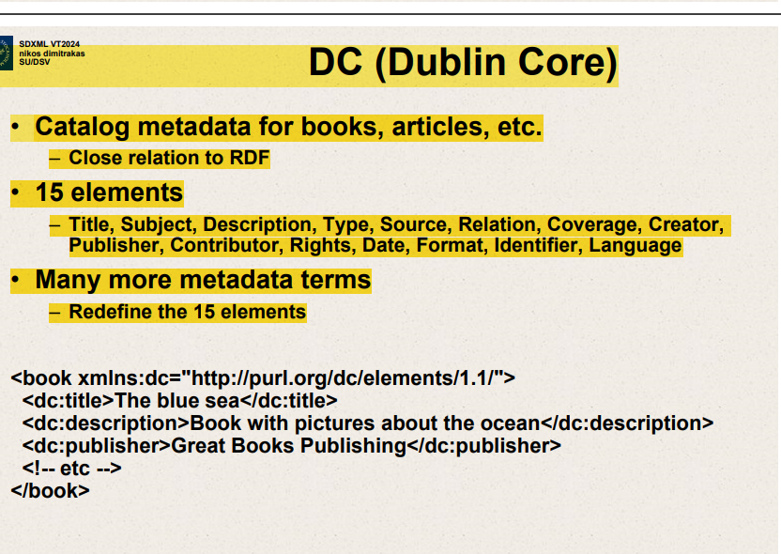

This slide presents an overview of the Dublin Core (DC) metadata element set, which is a standard for describing a wide range of resources. Here’s the breakdown:

1. **DC (Dublin Core)**: This indicates the subject of the slide, which is the Dublin Core, a set of vocabulary terms which can be used to describe digital resources (such as video, images, web pages, etc.), as well as physical resources such as books or CDs, and objects like artworks.
2. **Catalog metadata for books, articles, etc.**: This point explains that the Dublin Core is primarily used for cataloging information, like metadata for various resources including books and articles. It has a close relationship to RDF (Resource Description Framework), a framework for describing resources on the web.
3. **15 elements**: The Dublin Core standard includes 15 core elements that are used to describe the attributes of a resource comprehensively. These elements are listed:
   * Title
   * Subject
   * Description
   * Type
   * Source
   * Relation
   * Coverage
   * Creator
   * Publisher
   * Contributor
   * Rights
   * Date
   * Format
   * Identifier
   * Language
4. **Many more metadata terms**: Apart from the 15 standard elements, Dublin Core can be extended with more terms to redefine or add more detail to these elements.

At the bottom of the slide, there's an example of how these metadata elements are used in XML (eXtensible Markup Language) to describe a book:

* **<book xmlns:dc="http://purl.org/dc/elements/1.1/">**: This XML tag starts the definition of a book object. The **xmlns:dc** attribute declares a namespace for Dublin Core elements. The URL **http://purl.org/dc/elements/1.1/** is the namespace that indicates which version of DC elements is being used (version 1.1 in this case).
* **<dc:title>The blue sea</dc:title>**: Specifies the title of the book using the Dublin Core **title** element.
* **<dc:description>Book with pictures about the ocean</dc:description>**: Provides a description of the book using the Dublin Core **description** element.
* **<dc:publisher>Great Books Publishing</dc:publisher>**: Indicates the publisher of the book using the Dublin Core **publisher** element.
* **<!-- etc -->**: This is a comment in XML, suggesting that other Dublin Core elements could follow to provide more metadata about the book.
* **</book>**: Closes the XML element for the book.

This XML snippet serves as an example of how to use the Dublin Core within XML to provide structured, descriptive information about resources.

MathML

CML -Chemical Markup Language

Chemical formulas

RecipeML

Describes recipes

Describes ingredients, steps to produce dish you want.

ODF

For representing documents, spreadsheets,presentations.

Any math formula inside document will be using MathML.

Connects back to RDF and DC.

RDF – every graph is a resource has a unique identifier.

Odt file

Save a file as .odt.zip can see all the files

Exactly same thing – OOXML

Microsoft’s counterpart to ODF

5 smaller languages

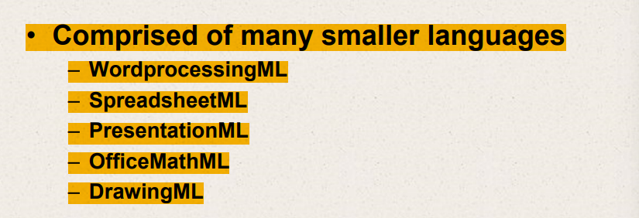

Save as docx

Save as hello.odt.docx

SVG – represents 2D graphics

Vector graphics,images,text,interactivity,animation.

Supported in most web browsers

Wsdl –Web Services Description Language

Defining how system can use web service

Define what is sent to server.

Define types like customerName

Used to describe Web Services

WSDL stands for Web Services Description Language.

System can use web services

It's an XML-based language used to define web services and describe how to communicate with them.

Something that gives the temperature and time at a specific place.

Essentially, it acts as a contract between the service provider and the consumer, detailing the format and protocol to be used for information exchange.

Here's a breakdown of its primary components:

1. **Types**: Defines the data types used by the web service. It typically imports XML Schema definition language (XSD) elements which describe the structure of the data.
2. **Message**: A message is an abstract, typed definition of the data being communicated. A message consists of logical parts, each of which is associated with a definition within some type system.
3. **Operation**: An operation is an abstract description of an action supported by the service. Each operation refers to an input message and output message.
4. **Port Type (Interface in WSDL 2.0)**: An abstract set of operations supported by one or more endpoints, it describes the operations that can be performed and the messages involved.
5. **Binding**: Specifies the protocol and data format for each port type. It defines the details of how a web service is accessed over the network, such as whether to use SOAP or HTTP GET/POST, and the format for request and response messages.
6. **Service**: Defines the ports (or endpoints) that the web service is available at. A service contains a set of related endpoints, where an endpoint is defined by a combination of a binding and a network address.

When a service is published using WSDL, a potential consumer can read the WSDL to determine what the service does and how it communicates. Tools can also automatically generate client-side proxies based on the WSDL, which can be used to interact with the service without having to deal with the underlying SOAP messages or network details.

RSS – Really Simple Syndication

Used mostly for news feeds, blogs, ads, etc.

Earlier RDF Site Summary with Relationship to RDF

AKA Rich Site Summary

Used with Dublin Core as RSS feeds have metadata.

WSDL – submit call need to be made to server and what to expect as result.

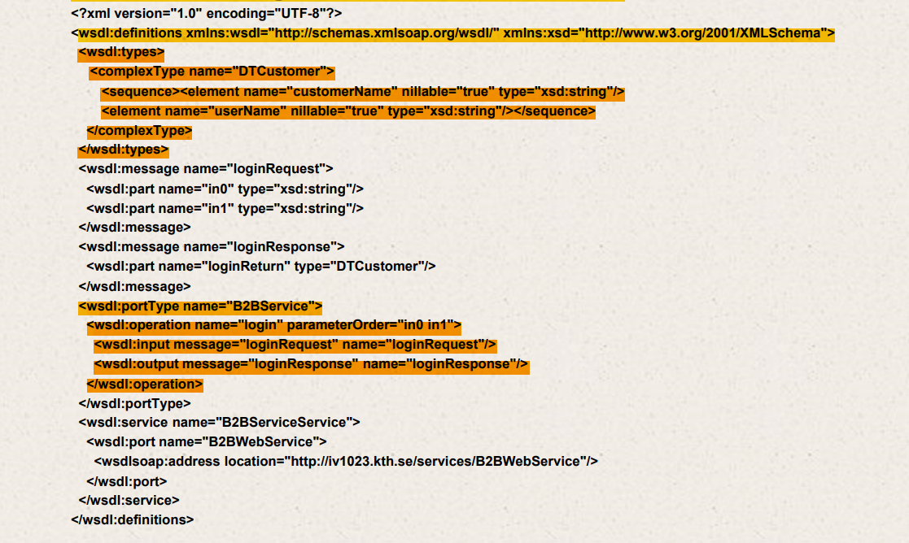

WSDL – Used to describe Web Services

Defines data types, defines calls and defines details about protocols.

RSS – Really Simple Syndication

RSS has really simple channels

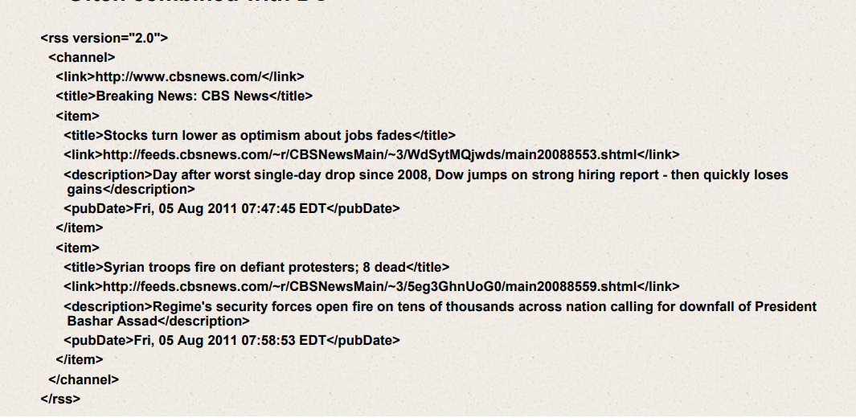

RDF – Resource Description Framework

Used to identify resources.

Identify resource uniquely with a URI.

State something about the resource.

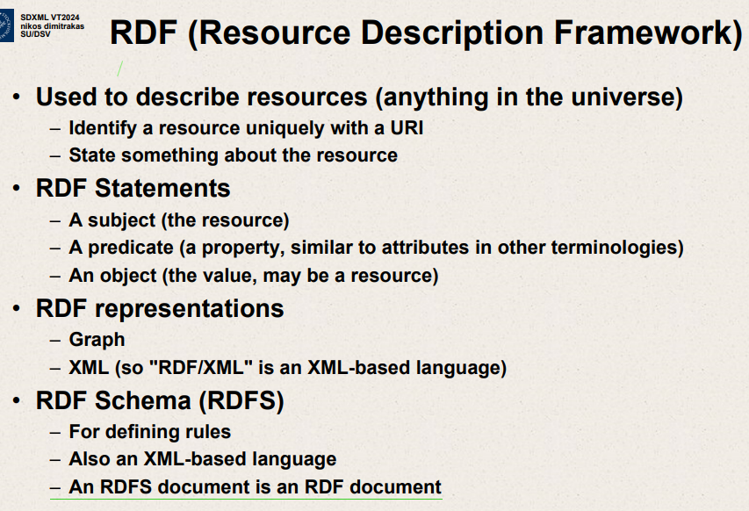

Used to describe resources

Identify resource uniquely with a URI

State something about resource

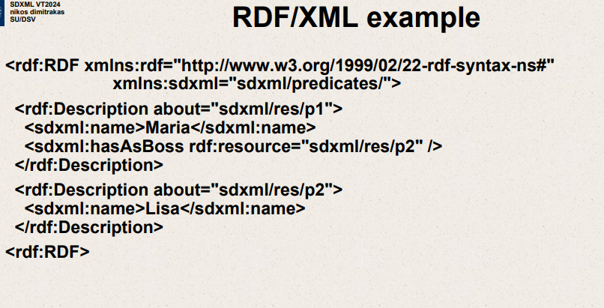

RDF statements have a subject ,a predicate and an object,

RDF ,DC and other languages.

Everything can be considered to be a resource.

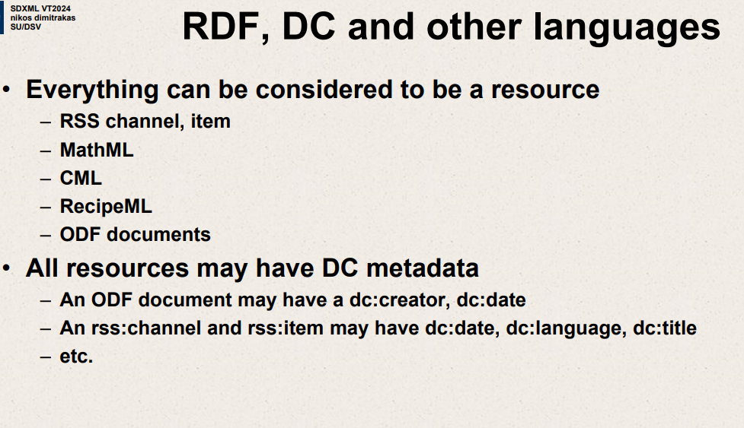

Open data

Availability – free to use

In standard format

CSV,XML,JSON,RDF

Open data

RDF,ODF,OOXML

Metadata in files

API’s – XML,JSON

Any API uses XML or JSON to transfer data between server and client.

Many protocols use XML.

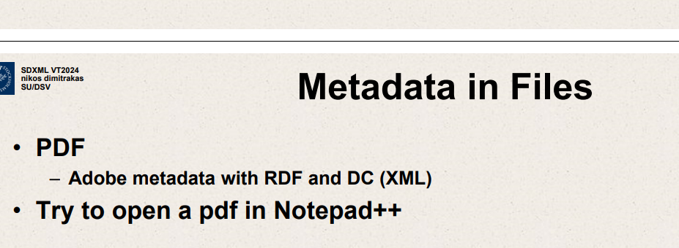

API’s

Send data or receive data

Input and output – JSON or XML

REST – Representational State Transfer

Ask for something,create something or delete something

SOAP -Simple Object Access Protocol

Sending messages as XML

GET  
JSON as response

Do GET on this HTTP

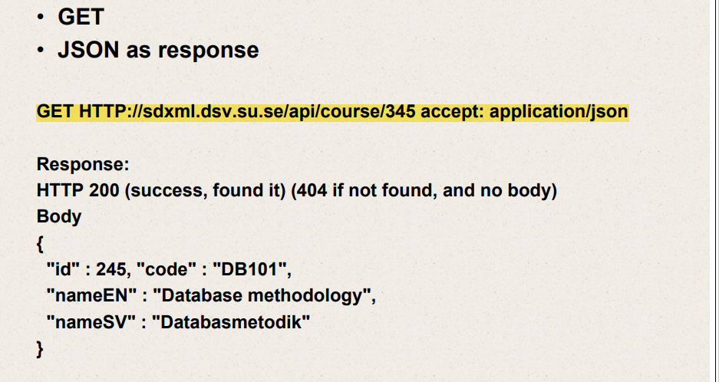

Models and languages for semi-structured data and XML

XML based languages

Usages of XML and SSD

XML based languages

Definition of structure

Definition of semantics

XML basic rules

-Alphabet,Vocabulary

XML schema(or DTD)

-Grammar,Syntax

XML schema annotations

Semantics,meaning

XML based languages

* Definition of structure
* Definition of semantics

XML basic rules

XML Schema (or DTD) - Grammar,syntax

XML Schema annotations(for humans)

DC (Dublin Core)

MathML

CML (Chemical Markup Language)

RecipeML

SVG( Scalable Vector Graphics)

WSDL (Web Services Description Language)

RSS (Really Simple Syndication)

RDF and RDFS (Resource Description Framework)

ODF (Open Document Format)

MathML

Representation of mathematical equations

Built in support in certain browsers

CML (Chemical Markup Language)

Representation of chemical formulas

ODF (open document format)

• For representing – documents – spreadsheets – presentations – graphs, diagrams, tables

• OASIS standard and ISO standard

• Uses MathML

• The latest version has a formal relationship to RDF and DC

JSON object

Label value pairs

Order should not matter

Labels should be unique

JSON array

Comma separated list

Order important

Items – objects, strings ,numbers,array.true,false.null

JSON -escaping

Some objects -escaped

“

Add \ inside strings

JSON schema

JSON syntax

Defines

Structures

Data types

Other restrictions

Schema keywords

$schema – JSON schema version

JSON schema

Enum

Const

JSON schema – objects

Validation Keywords

JSON schema

Uses JSON syntax

Defines

Structures ,data types ,other restrictions

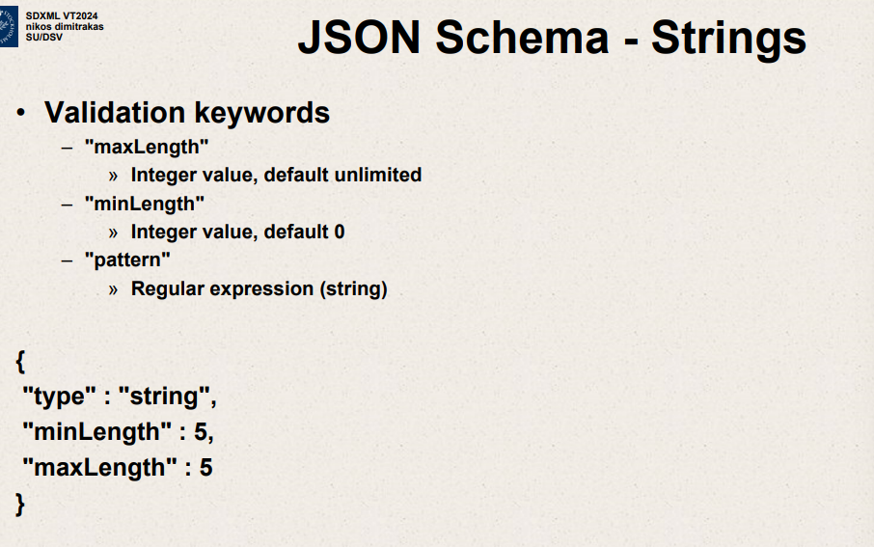

RDF

Resource Description Framework

Open Data

Free to use

REST API – Example

POST (create)

With JSON in request body

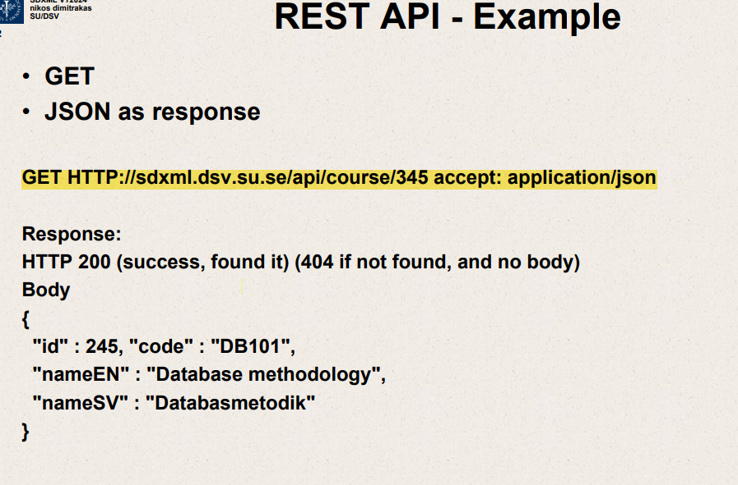

400 – client has error

500 -server has error

This is object you requested as JSON

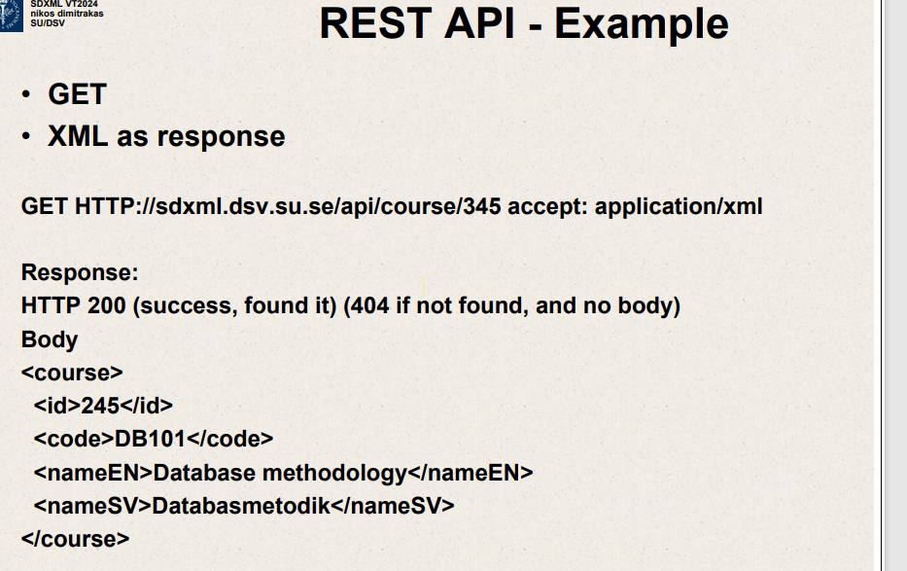

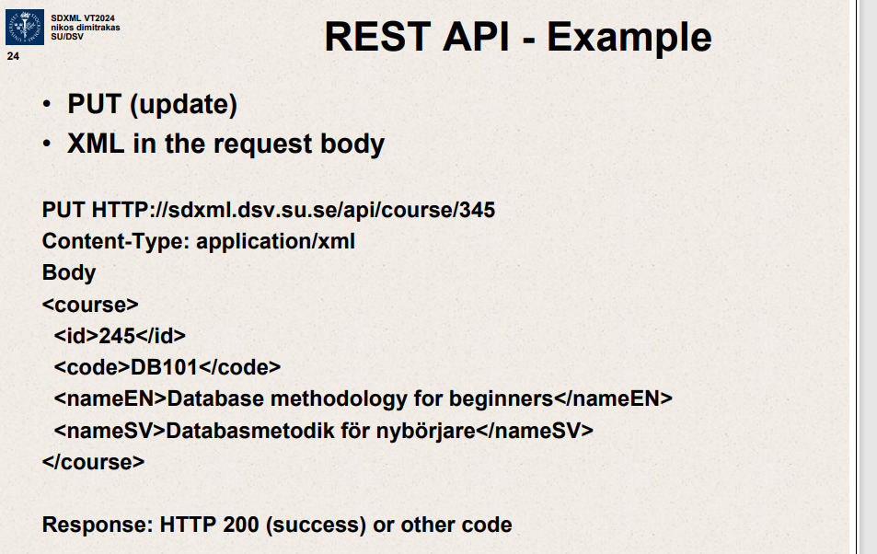

PUT – Already have an object you want to update.

POST – Want to create something

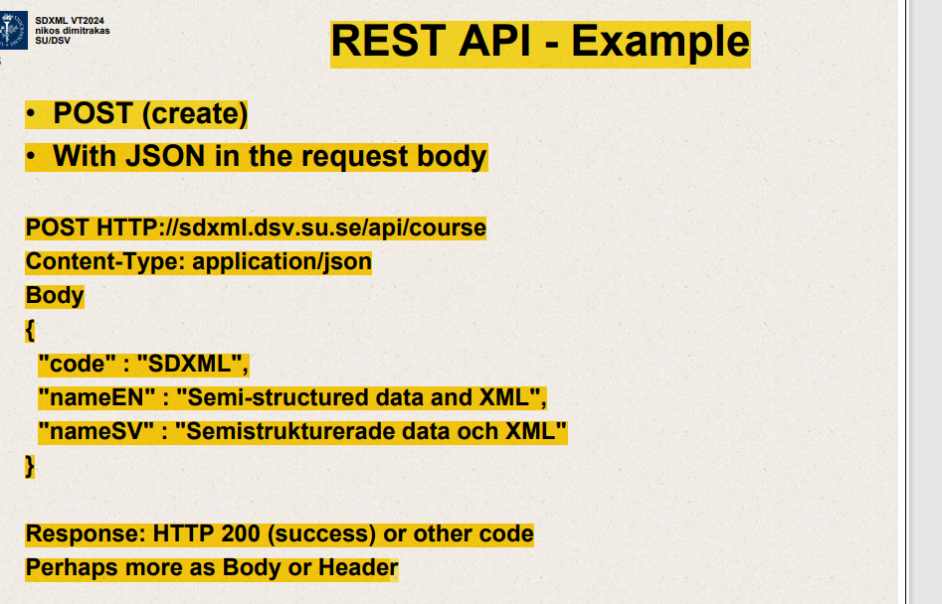

SOAP message -example

XML is in many configurations

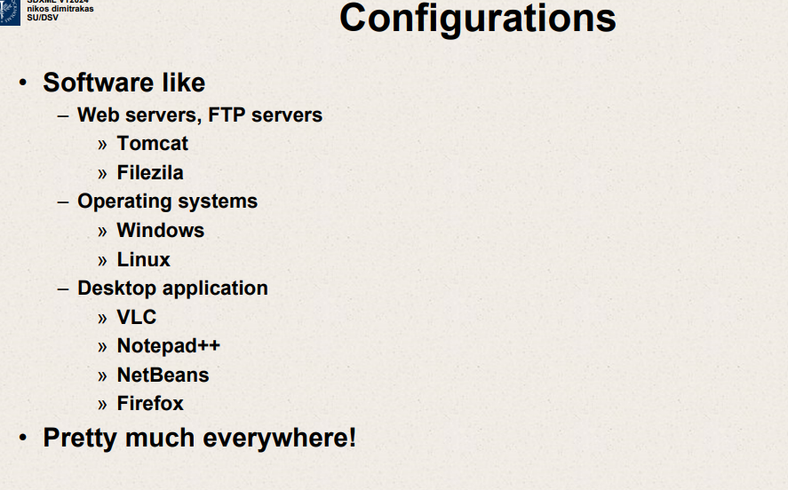

Maven –

Dependencies

Building

Want to create XML files

JavaFX with FXML

Spring

Beans

Injections

Transactions

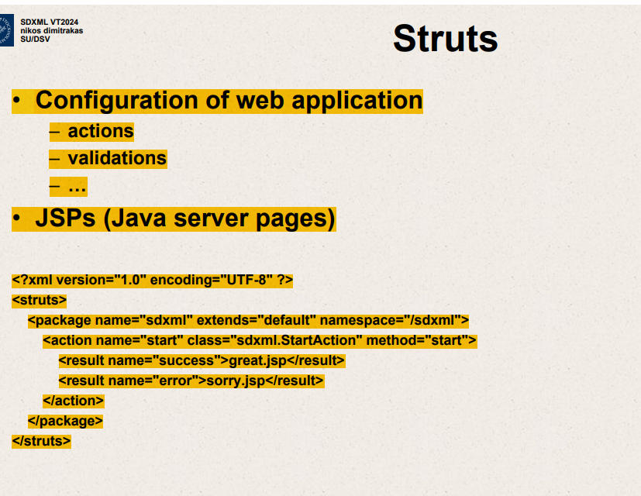

**XPath (XML Path Language)**

* **Purpose**: XPath is primarily used to select nodes and compute values from an XML document. Its main function is to navigate through the elements and attributes in an XML document.
* **Use Cases**: XPath is often used in scenarios where you need to extract information from an XML document or refer to specific parts of the document, such as in XSLT (Extensible Stylesheet Language Transformations) for transforming XML data or in XML schemas for specifying data constraints.
* **Capabilities**:
  + It provides a way to identify and select nodes in an XML document based on a variety of criteria, including element and attribute names, content values, and complex expressions.
  + XPath expressions can return sets of nodes, boolean values, numbers, and strings.
  + Simple conditional logic can be implemented through functions and predicates.

**XQuery (XML Query Language)**

* **Purpose**: XQuery is designed to query XML data and is capable of performing complex queries and transformations, similar to SQL but for XML. It goes beyond XPath by allowing the construction of new XML data.
* **Use Cases**: XQuery is used in applications where complex data retrieval, aggregation, and transformation are required. It's suitable for querying collections of XML data, constructing XML from various data sources, and transforming XML data into other formats.
* **Capabilities**:
  + It includes all the features of XPath for selecting and filtering elements.
  + It can construct new XML elements and documents.
  + It supports FLWOR (For, Let, Where, Order by, Return) expressions, which allow looping and sorting, similar to SQL's SELECT statements.
  + It provides more extensive functions and operators for string manipulation, numeric calculations, date handling, and more.
  + It can handle multiple documents and perform joins across different XML data sources.

**Key Differences**

1. **Scope**: XPath is a subset of XQuery in terms of functionality. XQuery includes all XPath capabilities and adds extensive query and data manipulation features.
2. **Data Manipulation**: XPath is used for simple queries and selecting parts of an XML document, while XQuery can perform complex queries, transformations, and create new XML structures.
3. **Complexity and Power**: XPath is simpler and more streamlined for quick queries within XML documents. XQuery, being more powerful, is better suited for applications that require manipulating or combining data from various XML sources.

Both languages are integral to XML data handling and are often used together in systems that need to extract and manipulate XML data extensively.

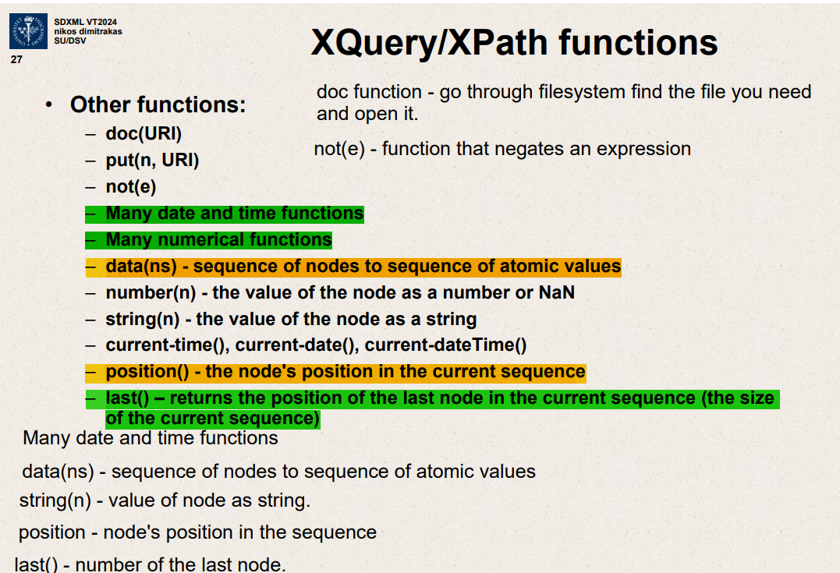Top of Form